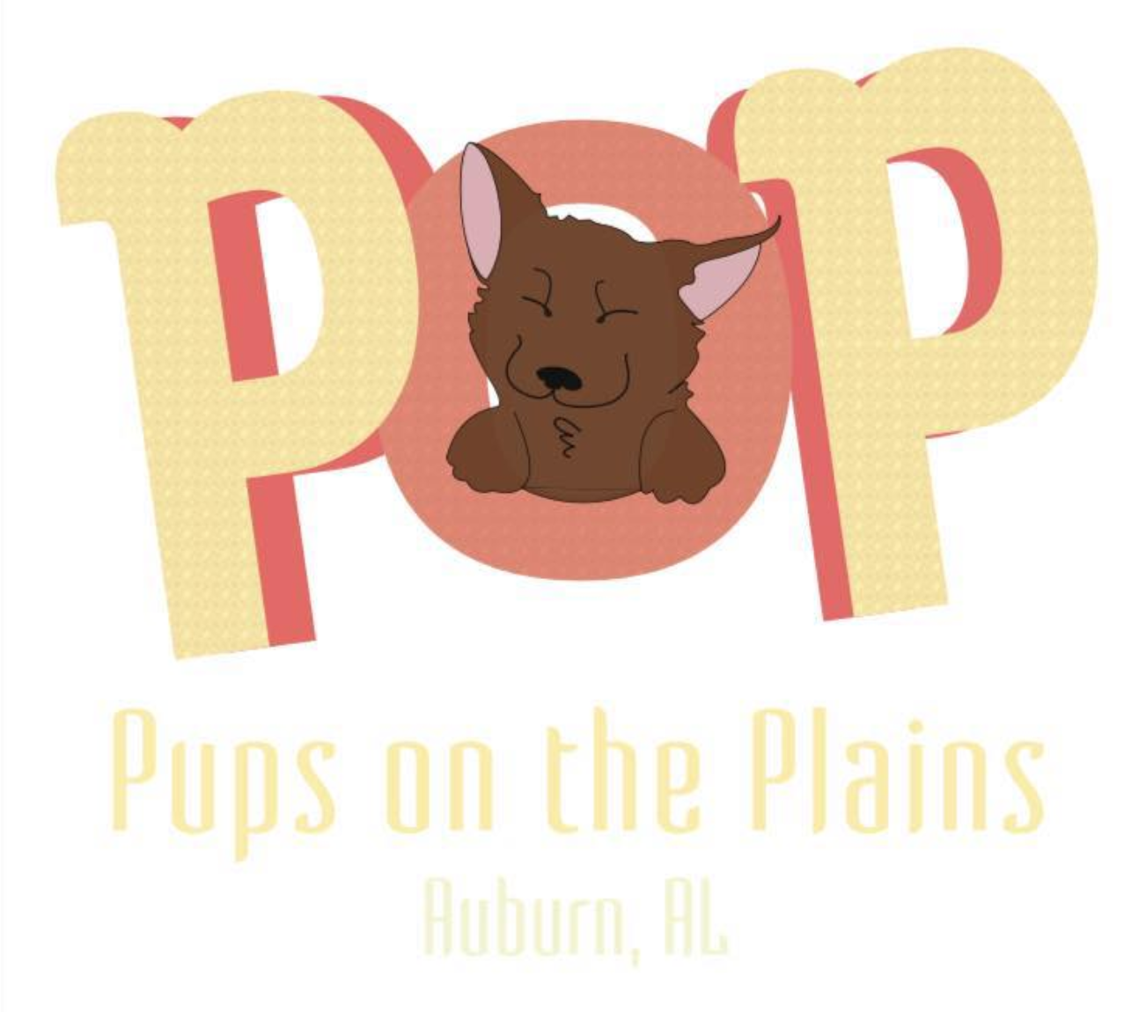

This is a legal document – please read carefully and be sure you understand it before signing.
I, (PRINT NAME HERE) _______________________________, have voluntarily applied to assist Pups on the Plains Rescue Team and/or its affiliates with the work referenced in the Position Description(s) for my volunteer role(s), and as specified in the Volunteer Agreement I signed.
By applying for and performing this volunteer work, I agree as follows and have initialed each item to indicate that agreement:
___ I am aware that this is a contract between me and POP and that it waives legal rights that I may have now or in the future and releases POP and others from claims for damages.
___ I AM VOLUNTARILY PARTICIPATING IN THIS ACTIVITY WITH FULL KNOWLEDGE OF THE TASKS INVOLVED. I AGREE TO ACCEPT ANY AND ALL RISKS ASSOCIATED WITH MY PARTICIPATION, INCLUDING BUT NOT LIMITED TO INJURY AND ILLNESS.
___ I understand I may not voice opinions contrary to POPs beliefs while volunteering. I understand that if I do this, I will be warned. If I get caught voicing opinions contrary to POPs beliefs more than once, I will be asked to take a break from volunteering and allow POP to decide if I can continue.
___ I understand there are risks and dangers associated with working with animals, including but not limited to, bites, scratches, zoonotic diseases (diseases transmitted from animals to humans), and allergic reactions. I also understand there may be risks involved with exposure to certain chemical cleaning products while performing my volunteer duties. I fully understand and accept those risks and dangers.
___ I fully assume all the risks involved with my volunteer activities, and acknowledge that they are acceptable to me. I agree to use my best judgment in undertaking these activities. I also agree to follow the rules and safety instructions as given by POP employees and volunteers authorized to act in a supervisory capacity.
___ I agree that I will not sue, prosecute, or in any way make a claim against POP for injury to me or damage to my property resulting from the negligence or other acts, howsoever caused, by any employee, agent, volunteer or contractor of POP or other people as a result of my volunteer duties.
___ I fully and forever release and discharge POP from any and all actions, causes of action, claims, liabilities, or demands I have or may have in the future, whether known or unknown, for injury, illness, death or damage arising out of or related in any way to my volunteer duties.
___ I agree that POP may use my name, and pictures, photographs, or video and/or sound recordings of me on television, on radio, on the Internet, in emails, and in stories, news articles, advertisements, or other written or digital materials. I agree that such uses may include education, advocacy, and fundraising. I consent to and authorize, in advance, such use and agree that POP does not have to notify me of such use or provide me with other consideration for such use. I waive any rights of privacy and/or publicity I may have in connection with these uses.
___ I agree that the rights I am giving up and agreements I am making apply equally to me and to my heirs, successors, assigns, guardians and legal representatives. I agree that none of those individuals may make any claim or take any action that I could not make or take myself.
___ I agree that this Waiver and Release of Liability protects and is for the benefit of Pups on the Plains Rescue Team, and also for its affiliates, and their respective employees, officers, directors, consultants, interns, volunteers, licensees, and all others acting on their behalf. I also agree that I may not make any claim or take any action against any of those affiliates or individuals that I could not make or take against POP itself.
___ I intend to fully and voluntarily waive any rights I have as described in this Waiver and Release of Liability. To the extent that legal consideration is required for this Waiver and Release of Liability to be effective, I agree that I have received good, valuable and sufficient consideration by being permitted by The HSUS to provide volunteer service and to receive training and instruction.
I HAVE CAREFULLY READ THIS WAIVER AND RELEASE AND FULLY UNDERSTAND ITS CONTENTS AND ACCEPT AND SIGN IT OF MY OWN FREE WILL. If I am under 18 years of age at the time of registration, my parent or legal guardian has completely reviewed this Waiver and Release of Liability, understands and consents to its terms, and authorizes my participation.

Printed Name of Volunteer
_____________________________________________________________________________ Signature of Volunteer and Date
_____________________________________________________________________________ Printed Name of Parent or Guardian (if under 19)
_____________________________________________________________________________ Signature of Parent or Guardian (if under 19) and Date
_____________________________________________________________________________ Printed Name of the POP Representative
_____________________________________________________________________________ Signature of the POP Representative and Date

